“Food for Thought: Nourishing Mental well-being in Vocational Training”

[FoodForThought]

Activity 3 - From Shopping to Cooking: Exploring Culinary Choices and Flavours in the Cultures of VET Students


T3.2. Cultural Culinary Exploring
As part of the Erasmus+ project Food for Thought: Nourishing Mental Well-Being in Vocational Training, the activity Cultural Culinary Exploring was designed to explore the connections between food culture, healthy dietary choices, sustainability, social interaction, and mental well-being. Through a multicultural dinner and collaborative cooking activities, participants experienced first-hand how food can serve as a powerful tool for promoting health, inclusion, intercultural understanding, and emotional well-being among VET students.
This activity brought together students and staff from different cultural backgrounds, creating an environment that encouraged cooperation, knowledge exchange, and social engagement through food-related experiences.

Objectives
The main objectives of the Cultural Culinary Exploring activity were:
- To promote awareness of healthy and balanced dietary choices that support mental well-being;
- To explore the relationship between nutrition and emotional health among VET students;
- To encourage intercultural dialogue through the sharing of culinary traditions;
- To strengthen teamwork and social connections through collaborative cooking activities;
- To promote sustainable food consumption through the use of local and seasonal ingredients;
- To highlight the role of food as a means of fostering inclusion, community engagement, and social well-being.

Multicultural Dinner and Team Cooking Activity
A central component of the activity was the preparation and sharing of a multicultural dinner. Participants worked in international teams to prepare a variety of dishes inspired by their national food traditions while incorporating principles of healthy nutrition and sustainable food consumption.
The collaborative cooking process encouraged active participation, communication, and cooperation among VET students from different countries. Working together in the kitchen created opportunities for informal learning, cultural exchange, and the development of interpersonal skills. Participants shared recipes, cooking techniques, food traditions, and personal experiences related to food and well-being, fostering mutual understanding and respect for cultural diversity.
The multicultural dinner provided a practical example of how food can bring people together and create positive social interactions. Sharing meals in a relaxed and inclusive environment contributed to strengthening social bonds and enhancing participants’ sense of belonging and community.
Sustainability was an integral component of the Cultural Culinary Exploring activity. The meals were prepared using predominantly local, seasonal, and short-supply-chain ingredients, following the principle of “zero-kilometre” (Km 0) food sourcing whenever possible.
Participants learned about the environmental benefits of choosing locally produced ingredients, including:
- Reduced transportation-related carbon emissions;
- Support for local farmers and producers;
- Preservation of regional food traditions;
- Increased transparency and traceability within food systems;
- Promotion of sustainable consumption patterns.
By cooking with locally sourced ingredients, participants gained a deeper understanding of how everyday food choices can contribute to environmental sustainability while also supporting local economies and community resilience.

Learning Outcomes
Through the Cultural Culinary Exploring activity, participants:
- Increased their awareness of the relationship between nutrition and mental well-being;
- Developed a better understanding of healthy food choices and sustainable eating habits;
- Enhanced intercultural communication and teamwork skills;
- Gained practical experience in collaborative meal preparation;
- Explored the social role of food in building communities and fostering inclusion;
- Learned about the benefits of local and sustainable food systems;
- Reflected on the contribution of food-related activities to emotional well-being and quality of life.
The Cultural Culinary Exploring activity successfully demonstrated the strong connections between food, health, sustainability, and social well-being. The multicultural dinner and collaborative cooking experience provided participants with valuable opportunities to explore how healthy dietary choices, local food systems, and positive social interactions contribute to mental well-being among VET students.
By combining intercultural learning, practical cooking activities, and sustainability principles, the activity supported the objectives of the Food for Thought: Nourishing Mental Well-Being in Vocational Training project. The experience reinforced the idea that food is not only a source of nutrition but also a powerful catalyst for social connection, cultural exchange, personal well-being, and sustainable development.
This report presents some traditional Romanian food products that were introduced during the Cultural Culinary Exploring activity. The products were selected due to their cultural significance, their connection to Romanian culinary traditions, and their role in bringing people together through shared meals and celebrations.

- Platou Tradițional Românesc cu Ceapă, Telemea, Șuncă și Roșii / Traditional Romanian Platter
The traditional Romanian platter composed of onion, leek, telemea cheese, cured ham or bacon, and fresh tomatoes is a simple yet representative example of Romanian rural gastronomy. This type of meal has been consumed for generations by farming communities, particularly during the spring and summer seasons when fresh vegetables are readily available. It reflects the principles of traditional food systems based on locally produced ingredients, seasonal consumption, and minimal processing.
This platter is often served as an appetizer, a light meal, or as part of a larger communal gathering. It highlights the richness of Romanian culinary heritage while promoting the use of local products sourced from nearby farms and household producers. Due to its simplicity and nutritional balance, the platter combines proteins, healthy fats, vitamins, minerals, and fresh vegetables, contributing to a satisfying and wholesome meal.
Within the context of the Food for Thought project, the traditional platter demonstrates how local foods and shared eating experiences can support social interaction, cultural identity, and well-being. The use of locally sourced ingredients also contributes to sustainability by reducing food miles and supporting regional food producers.

Recipe

Ingredients
- Telemea cheese: 300 g
- Traditional smoked ham or bacon: 300 g
- Fresh tomatoes: 4–5 u
- Red or white onion: 2 u
- Optional: Fresh parsley: 1 small bunch
- Optional: radishes: 10 u
- Optional: cucumber: 1 u
- Optional: Traditional country bread: 1 loaf
- Fine sea salt: to taste

Preparation Method
- Wash the tomatoes, onions, parsley, and any additional vegetables thoroughly under running water.
- Cut the tomatoes into wedges or thick slices.
- Peel the onions and slice them into rings or wedges according to preference.
- Cut the telemea cheese into cubes, slices, or rustic pieces suitable for serving.
- Slice the smoked ham or bacon into thin pieces.
- Arrange the telemea, ham or bacon, tomatoes, and onions attractively on a large serving platter.
- Add radishes, cucumber slices, or other seasonal vegetables if desired.
- Garnish with fresh parsley to enhance both appearance and flavour.
- Serve alongside slices of fresh country bread.
- Season the tomatoes and onions lightly with salt immediately before serving.
- Encourage participants to assemble their own combinations of ingredients, creating personalized flavour pairings.
- Enjoy the platter as a communal meal, appetizer, or traditional accompaniment to other Romanian dishes.
The finished platter should showcase the natural colors, textures, and flavors of fresh local ingredients. Its simplicity reflects the essence of Romanian rural cuisine, where high-quality seasonal products require minimal preparation. Beyond its nutritional value, the traditional platter promotes social interaction and shared dining experiences, reinforcing the connection between food, cultural heritage, community engagement, and overall well-being.

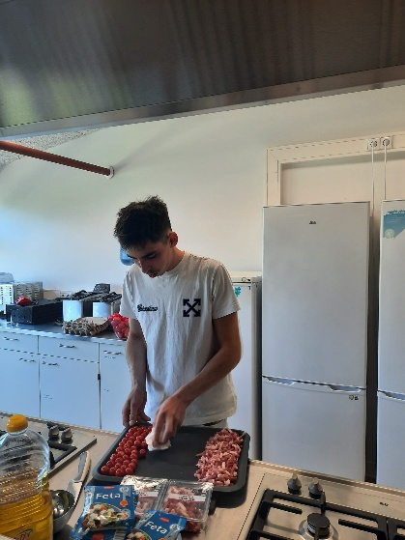 | 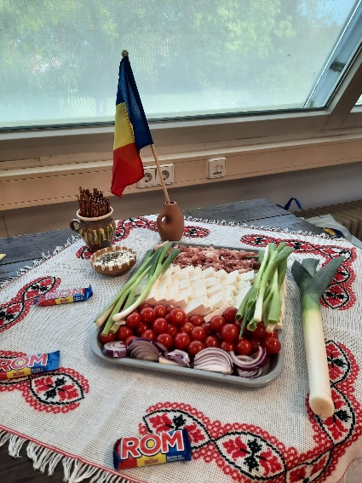
Figure 1. Pictures from preparing the Traditional Romanian Platter

- Ouă Roșii de Paște / Easter Red Eggs
Red Easter eggs are among the oldest and most meaningful traditions associated with the Romanian Easter celebration. The custom symbolizes rebirth, renewal, life, and the Resurrection of Christ. The preparation and decoration of Easter eggs represent an important family and community activity, bringing together different generations and strengthening cultural identity through shared traditions. In Romania, red eggs are traditionally served during the Easter meal and are used in the symbolic "egg tapping" ritual, which encourages social interaction and togetherness. The ingredients required are simple and widely available, making this preparation accessible throughout Europe while maintaining its cultural significance.

Recipe

Ingredients
- Fresh eggs: 12 u
- Water: approximately 2 L
- White vinegar: 2 tablespoons
- Red food colouring or natural red dye (onion skins, beetroot, or red cabbage): as needed
- Vegetable oil: 1 tablespoon (optional, for polishing)

Preparation Method
- Carefully wash the eggs under running water to remove any impurities from the shell surface.
- Place the eggs in a large saucepan and cover them completely with cold water.
- Add the vinegar to the water. This helps the colouring adhere more effectively to the eggshell.
- Add the red colouring agent according to the manufacturer's instructions or prepare a natural dye solution using red onion skins or beetroot.
- Place the saucepan over medium heat and slowly bring the water to a gentle boil.
- Once boiling, continue cooking the eggs for approximately 10–12 minutes to ensure they are fully hard-boiled.
- Remove the saucepan from the heat and allow the eggs to remain in the colouring solution for several minutes until the desired shade of red is achieved.
- Carefully remove the eggs using a spoon and place them on paper towels or a cooling rack to dry naturally.
- Once completely dry, gently rub each egg with a small amount of vegetable oil using a soft cloth or paper towel. This step gives the eggs a characteristic glossy appearance.
- Arrange the eggs in decorative baskets or serving dishes for the Easter celebration.
- Before consumption, participants traditionally engage in the Easter egg tapping ritual, where two people gently strike their eggs together while exchanging seasonal greetings.
- Serve the eggs as part of the traditional Easter meal, often accompanied by bread, cheese, lamb dishes, and other festive foods.
The finished Easter eggs should display a vibrant red color and a glossy surface. Beyond their nutritional value, they represent an important symbol of Romanian cultural heritage, family unity, social interaction, and emotional well-being, reflecting the project's emphasis on the connection between food traditions, community engagement, and mental well-being.
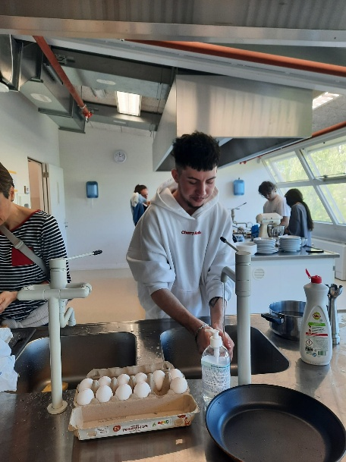 | 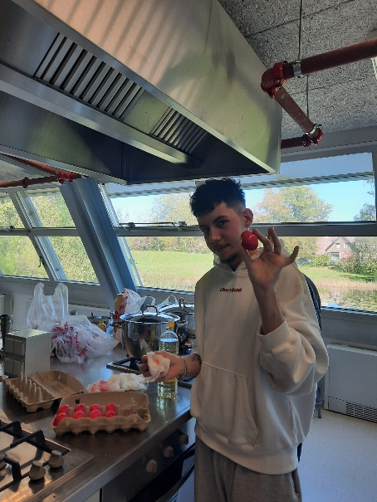
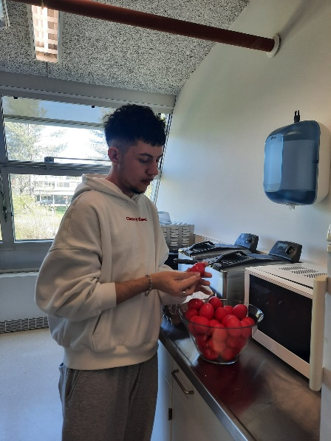 | 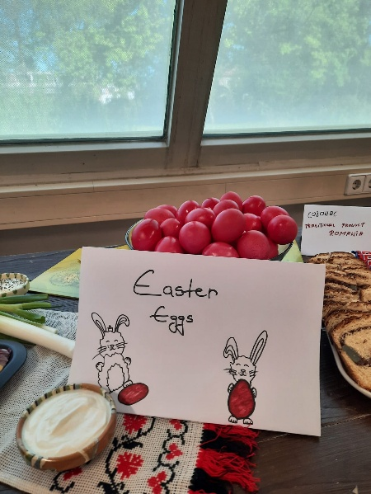
Figure 2. Pictures from preparing red Easter eggs

- Supă Cremă de Roșii / Creamy Tomato Soup
Creamy tomato soup is a popular and nutritious dish prepared throughout Europe, valued for its simplicity, rich flavor, and high nutritional content. In Romania, tomato-based soups are traditionally prepared during the summer season when fresh tomatoes are abundant and at their peak quality. The dish highlights the importance of seasonal and locally sourced ingredients, making it an excellent example of sustainable and healthy cooking.
Tomatoes are rich in vitamins A and C, antioxidants such as lycopene, and other bioactive compounds associated with health benefits. As part of a balanced diet, tomato soup can contribute to overall well-being while providing comfort and promoting healthy eating habits. Within the context of the Food for Thought project, this recipe demonstrates how simple plant-based meals can support both physical and mental well-being through nutritious ingredients and enjoyable food experiences.

Recipe

Ingredients
- Fresh ripe tomatoes: 2 kg
- Onion: 2 u
- Carrots: 2 u
- Garlic cloves: 4 u
- Sunflower oil or olive oil: 30 ml
- Vegetable stock: 1.5 L
- Tomato paste: 2 tablespoons (optional)
- Fresh basil: 10 leaves
- Fine sea salt: to taste
- Black pepper: to taste
- Optional: cooking cream (100 ml) for a creamier texture
- Optional: croutons for serving

Preparation Method
- Wash the tomatoes thoroughly and remove any damaged parts.
- Score a small cross on the bottom of each tomato and blanch them in boiling water for approximately 1 minute.
- Transfer the tomatoes immediately into cold water and remove the skins.
- Chop the peeled tomatoes into large pieces and set aside.
- Peel and finely chop the onions, carrots, and garlic.
- Heat the oil in a large saucepan over medium heat.
- Add the onions and carrots and cook gently for 5–7 minutes until softened.
- Add the garlic and continue cooking for an additional minute while stirring continuously.
- Add the chopped tomatoes and tomato paste, if used.
- Stir well and allow the mixture to simmer for approximately 10 minutes.
- Pour in the vegetable stock and bring the soup to a gentle boil.
- Reduce the heat and simmer for 25–30 minutes until all vegetables become completely tender.
- Add the fresh basil leaves during the final few minutes of cooking.
- Remove the soup from the heat and blend using an immersion blender until a smooth and homogeneous consistency is obtained.
- If a creamier texture is desired, add the cooking cream and stir thoroughly.
- Season with salt and black pepper according to taste.
- Return the soup briefly to low heat if necessary, without bringing it to a vigorous boil.
- Serve hot, garnished with fresh basil leaves and accompanied by homemade croutons if desired.
The finished creamy tomato soup should have a smooth texture, vibrant red color, and a balanced flavor combining the natural sweetness and acidity of ripe tomatoes. Prepared from seasonal and locally sourced ingredients, this dish illustrates how sustainable food choices can provide nutritious, affordable, and enjoyable meals that contribute to healthy lifestyles and overall well-being.
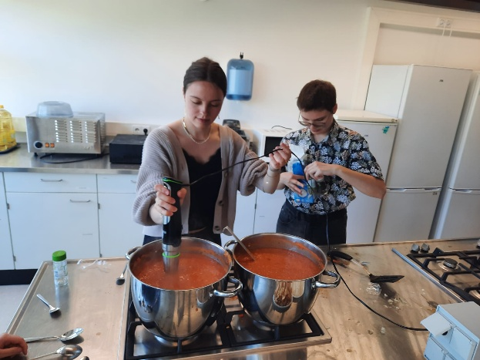 | 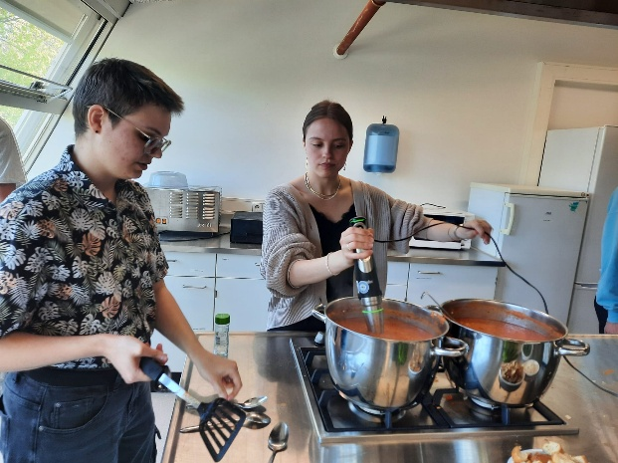
Figure 3. Pictures from preparing the Tomato soup

- Frigărui de Pui / Chicken Skewers
Chicken skewers are a popular dish in Romanian cuisine, frequently prepared for family gatherings, outdoor events, celebrations, and community meals. Their popularity stems from the simplicity of preparation, the use of fresh ingredients, and the possibility of combining meat with a variety of vegetables. Frigărui are associated with social dining experiences, where food preparation and cooking often become collective activities that encourage interaction and strengthen relationships among participants.
Within the context of the Food for Thought project, chicken skewers represent an example of a balanced meal that combines lean protein with fresh vegetables, supporting healthy eating habits and contributing to physical and mental well-being. The use of locally sourced ingredients also promotes sustainable consumption and short food supply chains.

Recipe

Ingredients
- Chicken breast: 1.5 kg
- Red bell peppers: 2 u
- Yellow bell peppers: 2 u
- Red onions: 2 u
- Zucchini: 2 u
- Cherry tomatoes: 20 u
- Sunflower oil: 50 ml
- Lemon juice: 50 ml
- Garlic cloves: 4 u
- Sweet paprika: 1 teaspoon
- Dried oregano: 1 teaspoon
- Fine sea salt: to taste
- Black pepper: to taste
- Wooden or metal skewers: 10–12 u

Preparation Method
- If using wooden skewers, soak them in water for at least 30 minutes to prevent burning during cooking.
- Wash and prepare all vegetables by removing seeds and cutting them into evenly sized pieces suitable for skewering.
- Trim any excess fat from the chicken breast and cut the meat into uniform cubes of approximately 3–4 cm.
- In a large mixing bowl, prepare the marinade by combining sunflower oil, lemon juice, crushed garlic, paprika, oregano, salt, and black pepper.
- Add the chicken pieces to the marinade and mix thoroughly to ensure all surfaces are evenly coated.
- Cover the bowl and refrigerate for at least 30 minutes, allowing the flavours to develop.
- Assemble the skewers by alternating pieces of marinated chicken with bell peppers, onion segments, zucchini slices, and cherry tomatoes.
- Preheat a grill, grill pan, or oven to approximately 200°C.
- Arrange the skewers evenly on the cooking surface, ensuring they are not overcrowded.
- Cook the skewers for approximately 12–15 minutes, turning them regularly to achieve even browning on all sides.
- Check that the chicken is fully cooked, reaching an internal temperature of at least 75°C.
- Remove the skewers from the heat and allow them to rest for 3–5 minutes before serving.
- Serve the chicken skewers hot, accompanied by fresh salads, grilled vegetables, or traditional sauces such as mujdei.
- Garnish with fresh herbs if desired and enjoy as part of a healthy and balanced meal.
The finished chicken skewers should be tender, juicy, and lightly charred on the outside, with colorful vegetables providing additional flavor, texture, and nutritional value. This preparation demonstrates how simple, locally available ingredients can be transformed into a nutritious meal that supports healthy lifestyles, sustainable food choices, and positive social interactions through shared dining experiences.
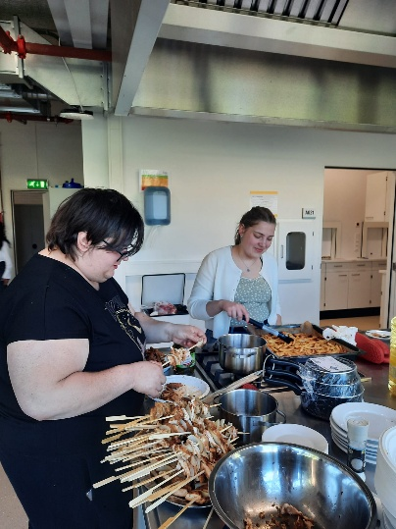 | 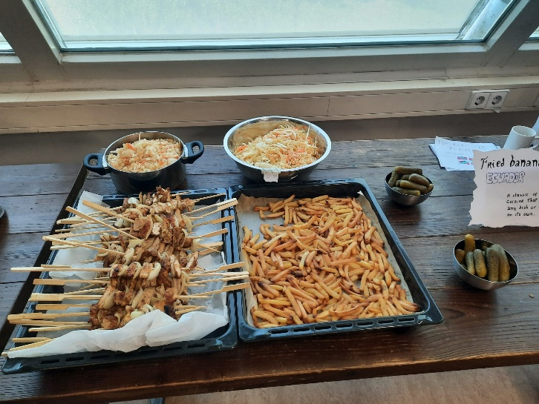
Figure 4. Pictures from preparing chicken skewer

- Cartofi Prăjiți la Cuptor / Oven-Baked Potatoes
Oven-baked potatoes are a healthier alternative to traditional deep-fried potatoes and are widely appreciated for their simplicity, nutritional value, and versatility. Potatoes have long been an essential component of Romanian cuisine and are among the most important crops cultivated throughout Europe. Rich in carbohydrates, fiber, vitamins, and minerals, potatoes provide a valuable source of energy and can be incorporated into balanced meals that support physical and mental well-being.
Within the framework of sustainable food consumption, oven-baked potatoes represent an example of a preparation that requires less oil than conventional frying methods while maintaining a pleasant texture and flavor. When prepared using locally grown potatoes, the dish also contributes to reducing food miles and supporting local agricultural production.

Recipe

Ingredients
- Potatoes: 2 kg
- Sunflower oil: 50 ml
- Sweet paprika: 1 teaspoon
- Dried rosemary: 1 teaspoon
- Fine sea salt: to taste
- Black pepper: to taste
- Optional: garlic powder, thyme, or parsley for seasoning

Preparation Method
- Preheat the oven to 200°C.
- Wash the potatoes thoroughly under running water to remove any soil or impurities.
- Peel the potatoes if desired, although leaving the skin on can increase the fiber content and nutritional value.
- Cut the potatoes into evenly sized sticks or wedges to ensure uniform cooking.
- Place the potato pieces in a large bowl and rinse briefly with cold water to remove excess surface starch.
- Drain the potatoes and pat them dry using clean kitchen towels or paper towels.
- Add the sunflower oil, paprika, rosemary, salt, and black pepper to the potatoes.
- Mix thoroughly until all potato pieces are evenly coated with the seasoning mixture.
- Line a baking tray with baking paper and arrange the potatoes in a single layer, avoiding overcrowding.
- Place the tray in the preheated oven and bake for approximately 35–45 minutes.
- Halfway through the cooking process, turn the potatoes using a spatula to promote even browning and crispness.
- Continue baking until the potatoes become golden brown on the outside and tender on the inside.
- Remove the tray from the oven and allow the potatoes to rest for 2–3 minutes before serving.
- Garnish with freshly chopped parsley or additional herbs if desired.
- Serve hot as a side dish or as part of a balanced meal accompanied by vegetables, salads, fish, or lean meat preparations.
The finished oven-baked potatoes should have a crispy golden exterior and a soft, fluffy interior. This preparation illustrates how simple local ingredients can be transformed into a nutritious and sustainable dish that supports healthy eating habits while preserving the familiar taste and comfort associated with traditional potato-based meals.
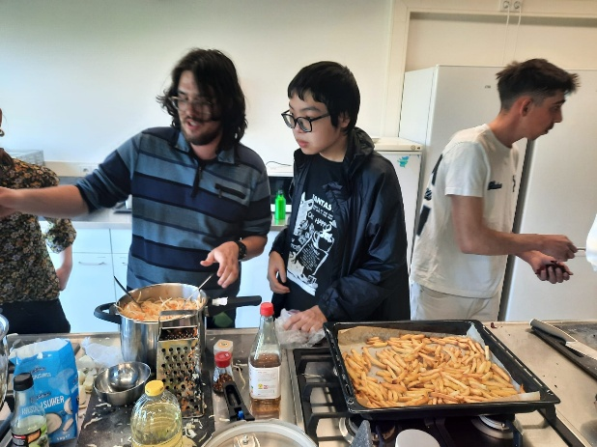 | 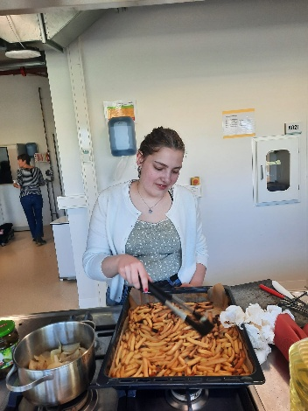
Figure 5. Pictures from preparing the oven-baked potatoes

- Salată de Varză cu Morcov / Cabbage and Carrot Salad
Cabbage and carrot salad is one of the most common and appreciated side dishes in Romanian cuisine. Prepared from simple, affordable, and locally available ingredients, this salad has long been a staple of both rural and urban households. It is frequently served alongside meat dishes, grilled foods, traditional platters, and seasonal meals.
This salad reflects the principles of healthy and sustainable eating by making use of fresh vegetables that can be cultivated locally throughout much of Europe. Cabbage and carrots are rich in dietary fiber, vitamins, minerals, and antioxidants, contributing to a balanced diet and overall well-being. Due to its freshness, nutritional value, and ease of preparation, this salad is often included in meals that promote healthy lifestyles and conscious food choices.
Within the framework of the Food for Thought project, cabbage and carrot salad represents an example of how simple plant-based foods can support both physical health and mental well-being. The use of seasonal and locally sourced vegetables also contributes to environmental sustainability and supports local agricultural production.

Recipe

Ingredients
- White cabbage: 1 medium head (approximately 1 kg)
- Carrots: 2–3 u
- Sunflower oil: 30 ml
- White wine vinegar or apple cider vinegar: 20 ml
- Fine sea salt: 1 teaspoon
- Freshly ground black pepper: to taste
- Optional: fresh parsley or dill for garnish

Preparation Method
- Remove any damaged outer leaves from the cabbage and wash it thoroughly.
- Cut the cabbage into quarters and remove the core.
- Finely shred the cabbage using a sharp knife or mandoline slicer.
- Transfer the shredded cabbage into a large mixing bowl.
- Sprinkle the cabbage with salt and gently massage it by hand for 2–3 minutes. This softens the texture and enhances flavour.
- Wash, peel, and grate the carrots using a coarse grater.
- Add the grated carrots to the cabbage.
- Pour the sunflower oil and vinegar over the vegetables.
- Season with black pepper according to taste.
- Mix all ingredients thoroughly until evenly combined.
- Allow the salad to rest for approximately 10–15 minutes before serving to allow the flavours to develop.
- Garnish with freshly chopped parsley or dill if desired.
- Serve chilled or at room temperature as a side dish accompanying meat, fish, potatoes, or other traditional meals.
The finished cabbage and carrot salad should have a fresh, crisp texture and a balanced flavor combining the natural sweetness of carrots with the mild acidity of vinegar. This traditional preparation demonstrates how simple local ingredients can be transformed into a nutritious, affordable, and sustainable dish that supports healthy eating habits, contributes to well-being, and complements a wide range of meals.
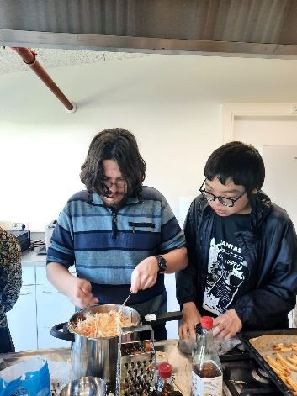 | 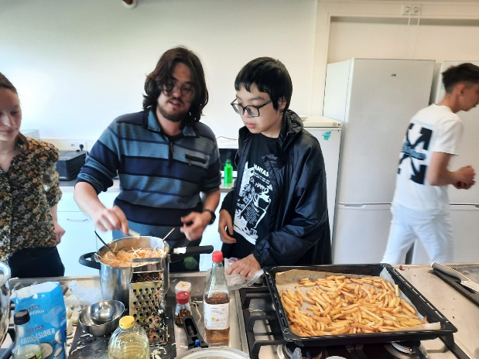
Figure 6. Pictures from preparing cabbage and carrot salad

- Mujdei de Usturoi / Traditional Romanian Garlic Sauce
Mujdei is one of the most popular traditional Romanian condiments, appreciated for its intense flavor and its versatility in accompanying a wide variety of dishes, particularly grilled fish, roasted meat, vegetables, and traditional meals. The preparation has deep roots in Romanian rural cuisine, where garlic has long been valued not only for its culinary properties but also for its perceived health benefits. Simple, nutritious, and made from locally available ingredients, mujdei reflects the principles of traditional sustainable cooking, where a few natural ingredients are transformed into a flavorful accompaniment that enhances the overall dining experience.
Garlic-based sauces are found throughout Europe; however, Romanian mujdei is distinguished by its simplicity and the prominent role of fresh garlic as the main ingredient.

Recipe

Ingredients
- Garlic cloves: 10–12 u (approximately 80–100 g)
- Sunflower oil: 50 ml
- Warm water or vegetable stock: 50–100 ml
- Fine sea salt: 1 teaspoon
- Optional: fresh parsley, finely chopped (1 tablespoon)
- Optional: sour cream or yogurt (2 tablespoons) for a milder version

Preparation Method
- Peel the garlic cloves and remove any damaged or discoloured parts.
- Place the garlic in a mortar and add the salt.
- Crush the garlic thoroughly using a pestle until a smooth paste is obtained. Alternatively, a garlic press may be used.
- Gradually add the sunflower oil while continuously stirring. This process helps create a smooth and slightly emulsified texture.
- Continue mixing until the garlic paste becomes creamy and homogeneous.
- Slowly add the warm water or vegetable stock while stirring continuously. Adjust the quantity according to the desired consistency.
- Taste and adjust the seasoning if necessary by adding a small amount of salt.
- If desired, incorporate finely chopped parsley to provide additional freshness and colour.
- For a milder variation, mix in sour cream or yogurt and stir until fully incorporated.
- Allow the mujdei to rest for approximately 10–15 minutes before serving. This resting period helps the flavours develop and harmonize.
- Transfer the sauce to a serving bowl and accompany it with grilled fish, roasted meats, vegetables, or traditional Romanian dishes.
- Serve fresh and consume within the same day for the best flavour and aroma.
The finished mujdei should have a smooth, creamy consistency and a strong, aromatic garlic flavor. Rich in natural bioactive compounds derived from garlic, it represents an example of how simple local ingredients can contribute to both culinary enjoyment and healthy eating habits. As a staple of Romanian gastronomy, mujdei also highlights the importance of traditional food knowledge, local ingredients, and shared meals in fostering cultural identity, social interaction, and well-being.
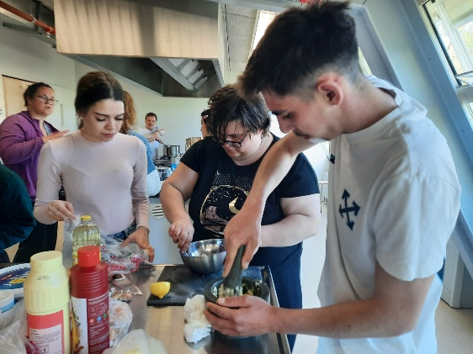 | 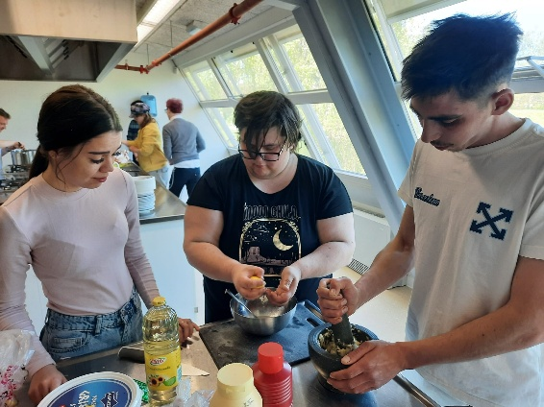
Figure 7. Picture from preparing mujdei

- Cozonac / Traditional Romanian Sweet Bread
Cozonac is one of the most iconic Romanian festive bakery products, traditionally prepared for Easter, Christmas, and other important family celebrations. Beyond its culinary value, cozonac represents an important element of Romania’s cultural heritage, bringing families together during its preparation and consumption. The recipe reflects the close connection between food, traditions, social interactions, and well-being. The ingredients used are widely available throughout Europe and can be sourced locally, supporting sustainable food systems and short supply chains.

Recipe

Ingredients
For the dough:
- Wheat flour: 1 kg
- Fresh milk: 500 ml
- Fresh yeast: 50 g
- Sugar: 200 g
- Eggs: 4 whole eggs + 1 egg yolk for glazing
- Butter: 100 g
- Fine sea salt: 1 teaspoon
- Vanilla extract: 1 teaspoon
- Lemon zest: from 1 lemon
For the filling:
- Ground walnuts: 300 g
- Sugar: 150 g
- Cocoa powder: 2 tablespoons
- Milk: 100 ml
- Raisins (optional): 100 g
- Turkish delight (optional): 100 g

Preparation Method
- Warm approximately 100 ml of the milk until lukewarm. Dissolve the yeast together with one tablespoon of sugar and leave it to activate for 10–15 minutes until frothy.
- In a large mixing bowl, combine the flour, remaining sugar, salt, vanilla extract, and lemon zest.
- Add the activated yeast mixture, the eggs, the remaining milk, and the melted butter to the dry ingredients.
- Mix thoroughly until all ingredients are incorporated and a homogeneous dough is formed.
- Knead the dough continuously for 20–30 minutes until it becomes smooth, elastic, and no longer sticks to the bowl.
- Cover the dough with a clean cloth and allow it to rise in a warm place for approximately 1.5–2 hours, or until it doubles in volume.
- While the dough is rising, prepare the filling by combining the ground walnuts, sugar, cocoa powder, and milk in a bowl. Mix until a spreadable paste is obtained.
- Once the dough has risen, divide it into four equal portions and lightly shape each portion into a rectangle using a rolling pin.
- Spread the walnut filling evenly over each rectangle. Add raisins or pieces of Turkish delight if desired.
- Roll each rectangle tightly into a log shape.
- Braid two logs together to form one cozonac and repeat with the remaining two logs.
- Transfer the braided dough into greased baking tins and allow it to proof for an additional 30–40 minutes.
- Brush the surface with beaten egg yolk to obtain a golden and glossy crust during baking.
- Preheat the oven to 180°C and bake the cozonaci for approximately 40–50 minutes, or until evenly browned and fully cooked.
- Remove from the oven and allow the loaves to cool in their tins for 10–15 minutes before transferring them to a wire rack.
- Let the cozonac cool completely before slicing. This resting period stabilizes the crumb structure and enhances the final texture and flavour.
The finished cozonac should have a soft, airy texture, a rich aroma of vanilla and citrus, and a sweet walnut filling, making it a centerpiece of Romanian festive meals and a symbol of hospitality, tradition, and family well-being.

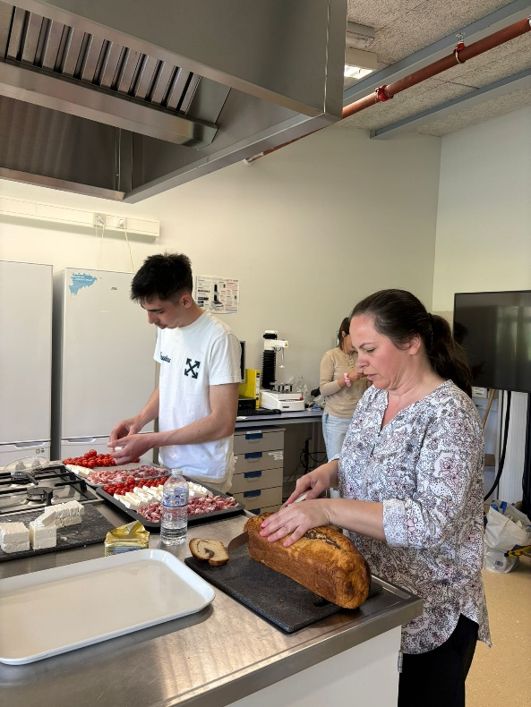 | 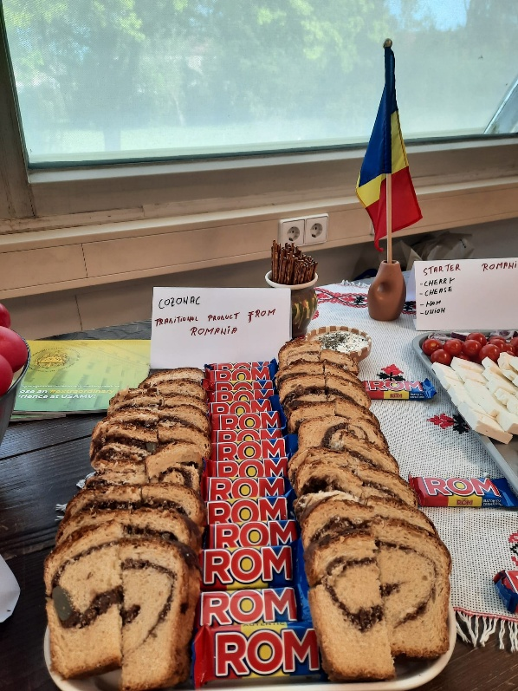
Figure 8. Pictures from preparing cozonac platter

- Tiramisu / Traditional Italian Coffee Dessert
Tiramisu is one of the most famous Italian desserts and has become popular worldwide due to its delicate texture and balanced combination of coffee, mascarpone cheese, and cocoa. The name Tiramisù literally means “pick me up” or “cheer me up,” reflecting the energizing effect of its coffee content. Originating in the Veneto region of Italy during the second half of the twentieth century, tiramisu is now considered an iconic example of European culinary heritage.
Within the context of the Food for Thought project, tiramisu illustrates how traditional recipes can bring people together through shared culinary experiences. Prepared and enjoyed in moderation as part of a balanced diet, desserts such as tiramisu contribute to social interaction, cultural exchange, and the enjoyment associated with communal meals, all of which are important aspects of well-being.

Recipe

Ingredients
- Mascarpone cheese: 500 g
- Fresh eggs: 4 u
- Sugar: 120 g
- Ladyfinger biscuits (Savoiardi): 300 g
- Strong brewed coffee: 300 ml
- Unsweetened cocoa powder: 30 g
- Vanilla extract: 1 teaspoon
- Optional: 2 tablespoons coffee liqueur or Marsala wine

Preparation Method
- Prepare the coffee and allow it to cool completely. If desired, add the coffee liqueur or Marsala wine and mix well.
- Separate the egg yolks from the egg whites into two clean mixing bowls.
- Add the sugar to the egg yolks and whisk until the mixture becomes pale, smooth, and creamy.
- Incorporate the mascarpone cheese gradually into the egg yolk mixture, stirring continuously until a homogeneous cream is obtained.
- Add the vanilla extract and mix thoroughly.
- In a separate bowl, beat the egg whites until stiff peaks form.
- Gently fold the whipped egg whites into the mascarpone mixture using a spatula, taking care not to deflate the mixture.
- Briefly dip each ladyfinger biscuit into the cooled coffee. Avoid soaking them for too long to prevent excessive softening.
- Arrange a single layer of coffee-soaked biscuits at the bottom of a serving dish.
- Spread half of the mascarpone cream evenly over the biscuit layer.
- Add a second layer of coffee-soaked biscuits on top of the cream.
- Cover with the remaining mascarpone mixture and smooth the surface using a spatula.
- Cover the dessert and refrigerate for at least 4–6 hours, preferably overnight, to allow the flavours to develop and the texture to stabilize.
- Just before serving, generously dust the surface with unsweetened cocoa powder using a fine sieve.
- Slice and serve chilled.
The finished tiramisu should have a soft, creamy texture with distinct layers of coffee-infused biscuits and mascarpone cream, finished with a delicate cocoa topping. As a dessert deeply rooted in European culinary culture, tiramisu demonstrates how food can contribute not only to nourishment but also to social connection, cultural appreciation, and the enjoyment of shared experiences that support overall well-being.
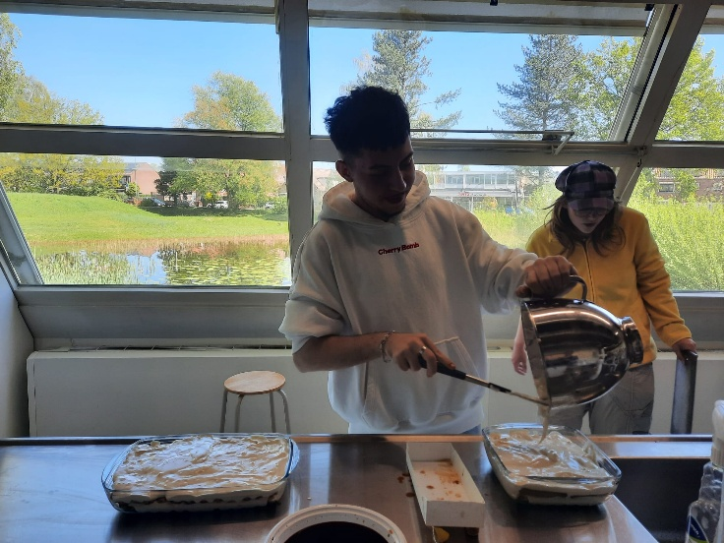 | 
Figure 9. Pictures from preparing Tiramisu dessert

