“Food for Thought: Nourishing Mental well-being in Vocational Training”

[FoodForThought]

Activity 3 - From Shopping to Cooking: Exploring Culinary Choices and Flavours in the Cultures of VET Students
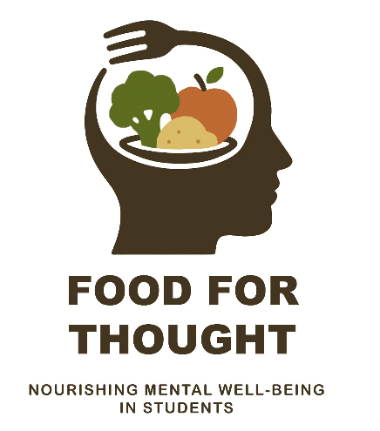

T3.3. Sustainability and Economics Analysis

As part of the Erasmus+ project Food for Thought: Nourishing Mental Well-Being in Vocational Training, a mobility activity involving students and academic staff was carried out at Van Hall Larenstein University of Applied Sciences (VHL), Velp, The Netherlands. The activities carried out during this mobility aimed to explore the relationship between sustainable food systems, nutrition, economic feasibility, and mental well-being within vocational education and training.
The activities focused on developing participants understanding of sustainable food production, responsible consumption, and the economic factors influencing the accessibility of healthy and nutritious food. Particular attention was given to the role of food systems in supporting mental health and well-being among students and young professionals.

Activities Performed
During the mobility, participants attended lectures, workshops, and field visits organized by VHL experts. The activities addressed several key topics:
- Sustainable food production and consumption models;
- Circular economy principles in agri-food systems;
- Environmental impacts of food choices;
- Economic aspects of sustainable nutrition;
- Accessibility and affordability of healthy food;
- The relationship between nutrition, lifestyle, and mental well-being;
- Innovative educational approaches for integrating sustainability into vocational training.
Students actively participated in group discussions and interdisciplinary teamwork, analyzing case studies related to sustainable food chains and evaluating the economic viability of various food production and consumption scenarios.

Sustainability Analysis
The sustainability component of the activity “From Shopping to Cooking” emphasized the importance of adopting food systems that are environmentally responsible, socially inclusive, and economically viable.
Participants examined:
- Resource-efficient agricultural practices;
- Reduction of food waste throughout the supply chain;
- Sustainable sourcing of raw materials;
- Local and seasonal food production;
- Circular approaches for valorising agricultural by-products.
Through field observations and practical examples provided by VHL, students gained insight into how sustainability principles can be applied in real-life food systems while simultaneously supporting public health objectives. Discussions highlighted that sustainable food choices contribute not only to environmental protection but also to improved physical and mental health outcomes.
To support the Sustainability and Economics Analysis task, the lecture “Food Trends – From Farm to Feed” was delivered during the mobility program. The lecture provided participants with a comprehensive overview of current developments in sustainable food systems, highlighting emerging trends in food production, processing, distribution, and consumption. Particular emphasis was placed on the transition from traditional linear supply chains to more sustainable and circular food systems, as well as on the economic and environmental implications of these changes. This presentation encouraged participants to critically analyze the challenges and opportunities associated with ensuring access to nutritious, affordable, and sustainably produced food. By examining the entire food value chain—from farm production to final consumption—the lecture contributed to a deeper understanding of how sustainable food choices can support both environmental objectives and human well-being. Furthermore, it offered valuable insights into the role of innovation, consumer behavior, and policy measures in shaping resilient food systems capable of promoting long-term physical and mental health.

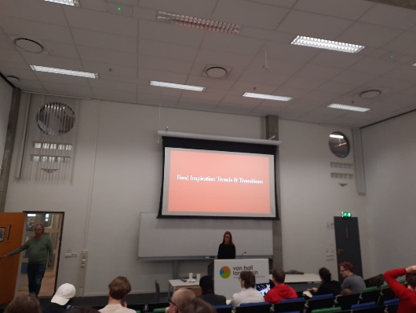 | 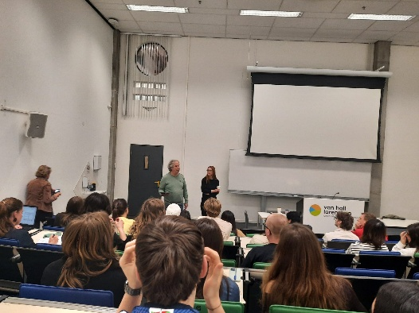
Figure 1. Picture from "Food Trends – From Farm to Feed" lecture
An important practical component of the activity was the study visit to De Velhorst (Lochem, The Netherlands), an organic farm and estate recognized as one of the only two professional grain producers in the Achterhoek region. During the visit, participants received a comprehensive tour of the farm and an overview of its activities, with a particular focus on sustainable land management practices, regenerative agriculture, and nature conservation.
The visit provided valuable insights into how agricultural production can be successfully integrated with biodiversity protection and ecosystem restoration. Participants learned about regenerative farming techniques aimed at improving soil health, enhancing carbon sequestration, increasing resilience to climate change, and reducing dependency on external inputs. The farm serves as an example of how environmentally responsible agricultural practices can contribute to long-term economic sustainability while maintaining productive farming systems.
Discussions with farm representatives highlighted the challenges and opportunities associated with organic grain production, local food systems, and sustainable value chains. The experience enabled students and staff to observe first-hand the practical application of sustainability principles discussed during the lectures and workshops, reinforcing the importance of balancing economic viability, environmental stewardship, and social responsibility within modern food systems.
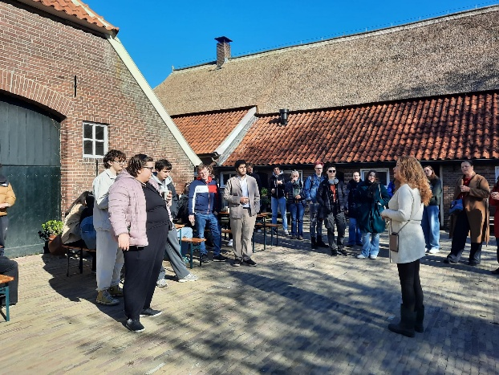 | 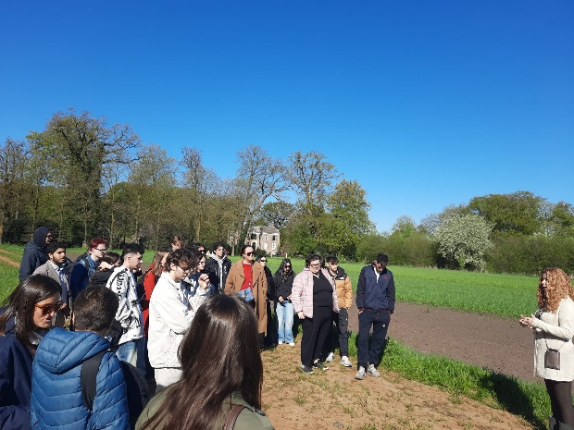
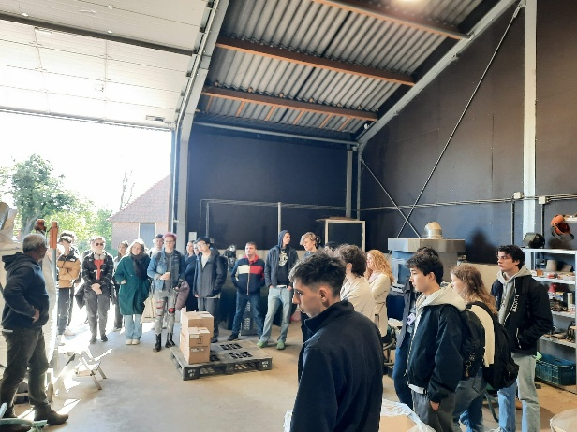 | 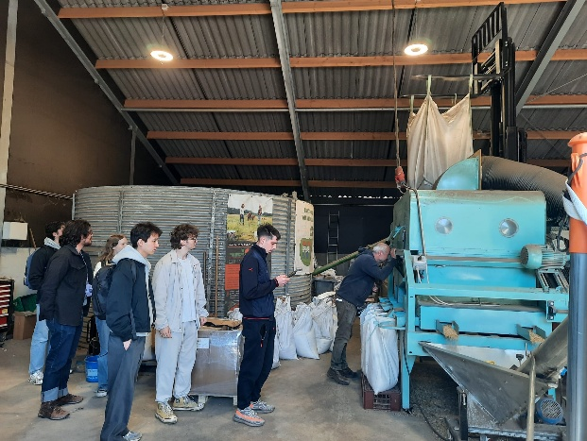
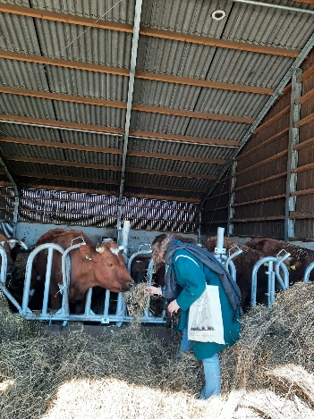 | 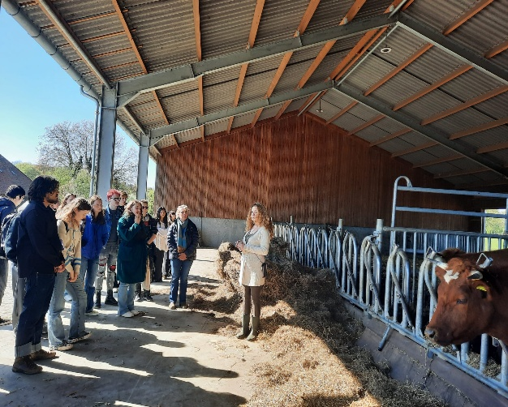
Figure 2. Pictures from the study visit to De Velhorst Farm (Lochem, The Netherlands)

Another significant learning activity within the Sustainability and Economics Analysis task was the visit to Stadsboerin Doetinchem, an urban farm and community food initiative located in the city of Doetinchem. The visit included a guided tour, a presentation of the farm’s activities, and a lunch prepared using locally grown produce. The experience highlighted the social dimension of sustainable food systems and demonstrated how food can serve as a powerful tool for community building, social inclusion, and well-being.
Participants learned how Stadsboerin combines urban agriculture, food production, education, and social support activities within a single community-based model. The initiative provides opportunities for volunteers, integration course participants, newcomers, migrants, schools, and local residents to work together in gardening, cooking, and educational activities. By creating a welcoming environment where people from diverse social and cultural backgrounds can interact, the farm project contributes to social cohesion, inclusion, and community resilience.
Particular attention was given to the role of food in fostering intercultural dialogue and social integration. Examples such as community meals and cooking activities involving newcomers demonstrated how shared food experiences can help reduce social isolation, encourage cultural exchange, and strengthen community ties. These activities align closely with the objectives of the Erasmus+ project, emphasizing the connection between nutrition, social participation, and mental well-being.
The visit also introduced participants to the Social Gastronomy Movement, an international network of organizations that use food as a catalyst for social change, inclusion, education, and sustainable development. As an active member of this network, Stadsboerin contributes to initiatives that promote equitable and inclusive food systems while encouraging collaboration among communities worldwide.
From an economic and sustainability perspective, Stadsboerin represents an innovative model in which food production generates not only environmental and economic value but also significant social benefits. The farm project demonstrates how local food initiatives can create opportunities for volunteering, learning, integration, and community development while simultaneously promoting healthy eating habits and sustainable consumption. The visit provided participants with valuable insights into the importance of considering social sustainability as an integral component of resilient food systems and of strategies aimed at improving mental well-being through food-related activities.

As part of the Sustainability and Economics Analysis task, participants took part in a guided visit to the historic city of Zutphen, followed by a period of independent exploration. The activity provided valuable insights into the economic dynamics of local communities and the contribution of small businesses, food producers, and cultural heritage to regional development.
During the guided tour, students were introduced to the historical and cultural significance of Zutphen, one of the oldest cities in the Netherlands. The visit highlighted how heritage preservation, local entrepreneurship, and sustainable tourism can contribute to economic resilience while maintaining the cultural identity of a region. Participants observed examples of locally owned businesses, artisan bakeries, cafés, and specialty food shops that play an important role in supporting the local economy and creating employment opportunities.
The free exploration period enabled students to engage directly with the local economic environment by visiting traditional Dutch bakeries, cafés, and retail establishments. These experiences offered practical examples of short supply chains, locally sourced products, and customer-oriented business models that contribute to sustainable economic development. Students were encouraged to reflect on consumer behavior, purchasing decisions, and the added value generated by local food products and services.
Particular attention was given to the role of food-related enterprises in promoting both economic sustainability and social well-being. Visits to local bakeries and cafés illustrated how food businesses can serve as community gathering spaces, supporting social interaction and contributing to quality of life. These observations complemented the project's broader focus on the relationship between food, community engagement, and mental well-being.
From an economic perspective, the Zutphen visit demonstrated how sustainable tourism and local food economies can generate multiple benefits, including support for local producers, preservation of traditional food practices, stimulation of regional markets, and diversification of income sources. The activity reinforced participants’ understanding of the interconnectedness between sustainable food systems, local economic development, and community well-being.
The visit also encouraged students to critically analyze how consumers influence sustainability through everyday purchasing choices and how local businesses can contribute to more resilient and inclusive food systems. These observations provided practical examples that complemented the theoretical concepts discussed throughout the mobility program and strengthened participants understanding of sustainability from both economic and social perspectives.

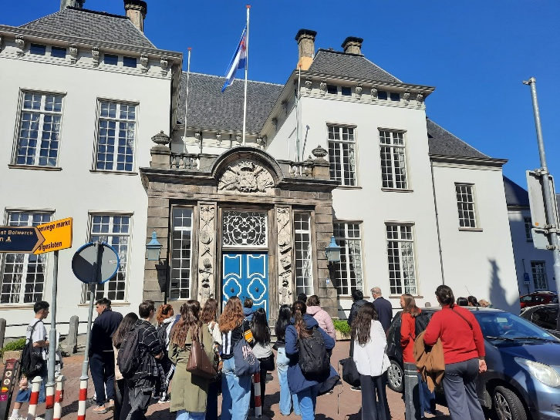 | 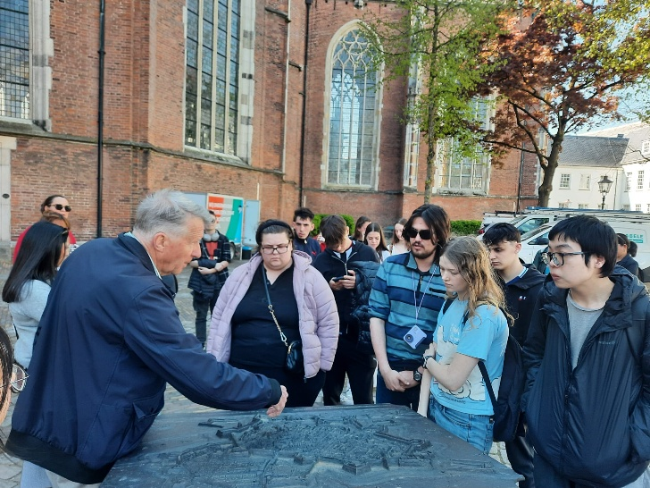
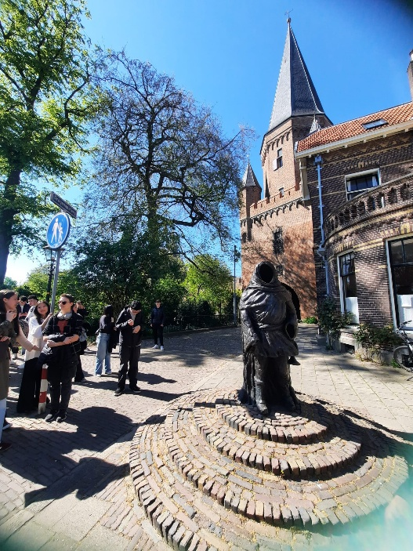 | 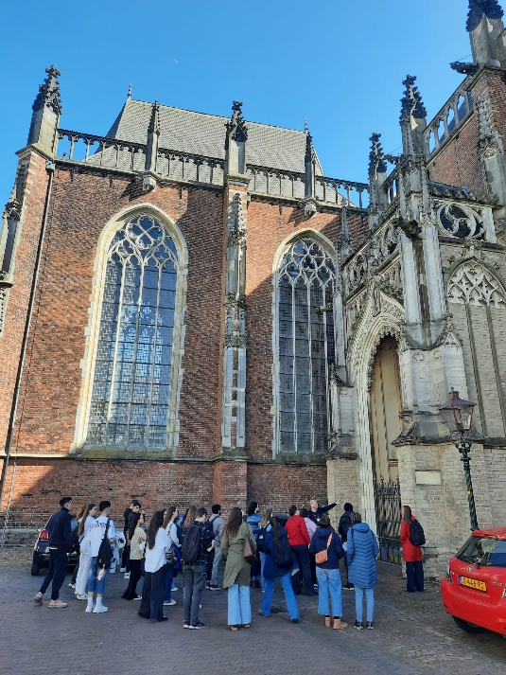
Figure 3. Images from the guided visit to the historic city of Zutphen

Economic Analysis
The economic component focused on assessing the feasibility and affordability of sustainable nutrition strategies.
Key aspects analyzed included:
- Production costs associated with sustainable food systems;
- Market opportunities for sustainable food products;
- Consumer behaviour and purchasing decisions;
- Cost-benefit analysis of healthy dietary patterns;
- Economic barriers affecting access to nutritious food.
Participants explored how economic factors influence food choices and how educational interventions can encourage healthier and more sustainable consumption patterns. The analysis demonstrated that investments in nutrition education and sustainable food practices may generate long-term benefits through improved health outcomes, increased productivity, and reduced healthcare costs.

Impact on Mental Well-Being
One of the central themes of the project was the connection between food and mental health. The mobility activities reinforced the understanding that balanced nutrition, food quality, and sustainable dietary habits play a significant role in supporting cognitive performance, emotional resilience, and overall well-being.
Students identified several factors that positively influence mental well-being:
- Access to nutritious and affordable food;
- Awareness of healthy eating habits;
- Social interaction through shared food experiences;
- Reduced environmental concerns through sustainable consumption choices.
The interdisciplinary approach adopted during the mobility encouraged participants to view nutrition as an essential component of mental health promotion within vocational education.

Learning Outcomes
The mobility enabled participants to:
- Develop knowledge of sustainable food systems and circular economy principles;
- Understand the economic dimensions of sustainable nutrition;
- Strengthen analytical and critical thinking skills;
- Improve intercultural communication and teamwork competencies;
- Gain practical experience through interaction with international experts and students;
- Enhance awareness of the links between nutrition, sustainability, economics, and mental well-being.
The mobility at Van Hall Larenstein University of Applied Sciences provided valuable opportunities for students and academic staff to deepen their understanding of sustainability and economic aspects related to food systems and mental well-being. The combination of theoretical learning, practical activities, and intercultural collaboration contributed significantly to achieving the objectives of the Food for Thought: Nourishing Mental Well-Being in Vocational Training project.
The experience demonstrated that sustainable and economically feasible food systems can play a crucial role in promoting mental well-being and supporting healthier lifestyles. The knowledge and competencies acquired during the mobility will be further disseminated and integrated into educational activities at the home institution, contributing to the long-term impact and sustainability of the project.

