Kick-off Meeting:
"KA210 - VET 32C3CD3E - Food for Thought: nourishing mental well- being in vocational training"
Organiser: CIFP Don Bosco LHII
Venue: Virtually - Meet
KA210- Food for Thought - Kick off Meeting
Monday, 27th October · 12:00 – 1:00pm
Zona horaria: Europe/Madrid
Link to event: https://meet.google.com/ufu-osdu-qbi
Participants:
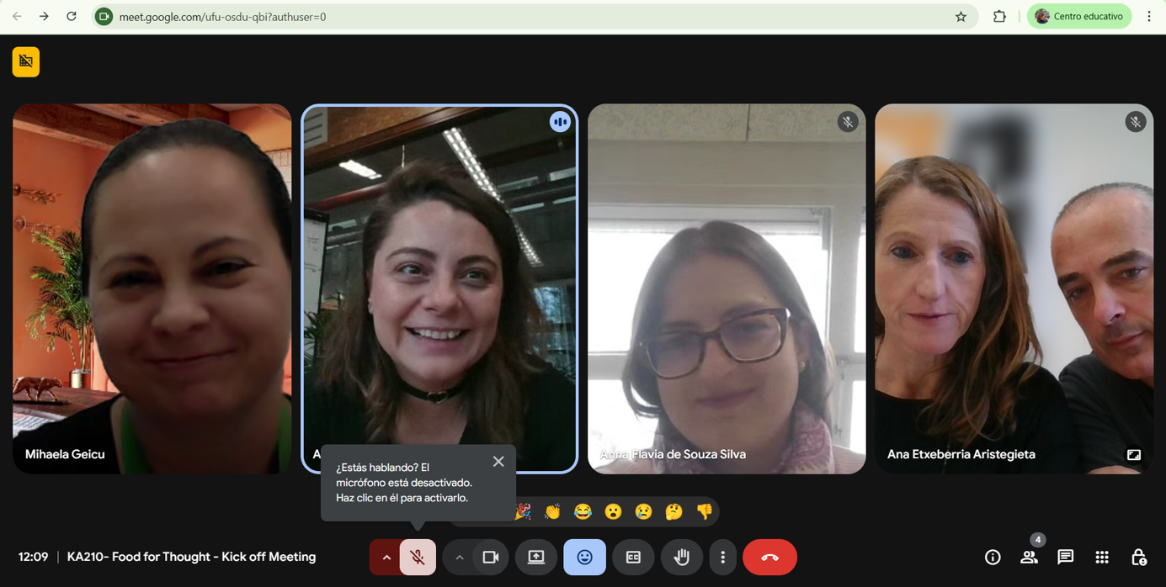
- CIFP Don Bosco LHII:
Ana Etxeberria Aristegieta
Xabier Irigoyen Garbizu
- Stichting Van Hall Larenstein (VHL):
Adriana Sterian
Anna Flavia de Souza Silva
- Universitatea de Stiinte Agronomice si Medicina Veterinaria Din Bucuresti (USAMV Bucuresti):
Mihaela Geicu

Agenda
1. Welcome and Introduction:
- A brief overview of the project journey and the importance of the Kick off meeting.
- Welcome remarks by the project head and acknowledgment of all partners.
It was time to proceed with the Kick off meeting without further delays.
2. Project Presentation:
- A detailed walkthrough of the project's objectives, goals, and the expected impact.
- Explanation of the importance of mental health and its connection with healthy nutrition.
Reminder of the submitted project which can be found in the following link: https://drive.google.com/drive/u/0/folders/1D8mpIhbjIswJeg37c0WbN9mUT_MfP-Vp
3. Partners’ explanations:
- Each partner gets its time to introduce their organization and explain their role and planning of the lead activities and how this will contribute to the project.
Each of us introduced ourselves. I met Anna Flavia de Souza Silva in July 2024 in an Erasmus+ trainers mobility back in 2024.
Adriana Sterian told us that she is pregnant and expecting the baby for March 2026 (is this correct Adriana?).
Very nice seeing you again Mihaela.

- Milestones, timeline and communication:
  - Laying out the project's timeline, milestones, and communication strategies.
  - Introduce any project management tools or platforms that will be used for collaboration.
We presented the shared folder to manage the project, which is available through the following link. Do let me know if you have problems accessing the folder.
https://drive.google.com/drive/u/0/folders/1fkQptnMkeFtJQAf_RVffo-5VJkHXJz7C
Below you can find an explanation of the content of each folder.
1.- Economic and Activity Control
Each partner needs to complete the “timeline” taking into account the activities they lead.
- Mihaela said that they have started working on “Activity 2. Cultivating Healthy Lifestyles: Analysing Nutritional Habits of VET students and Young Adults”.
Mihaela will prepare the questionnaires in English and each partner will translate, if they think it is necessary, into Spanish/Basque and Dutch.
- Adriana spoke about carrying out Activity 3 in The Netherlands in spring (dates to be confirmed). The sooner we know the dates, the better we will get organised.
- Activity 4 needs to be completed in the Basque Country before the end of May 2026 as our students finish attending CIFP Don Bosco LHII the 4-5th June 2026. Otherwise, Activity 4 will need to be completed from September 2026 onwards.

2.- Justification of Activities
https://drive.google.com/drive/u/0/folders/1Bn_Nz7VZo2RzqEqB7o4wo9B8B-kcLVQF
Photos, signatures of participants and any other relevant evidence/information, needs to be saved in each folder. Each participant will add their own evidence. Otherwise, send it to me at ana.etxeberria@donbosco.eus and I will add it.
3.- Economic Justification and Invoices
We attended a two day long workshops/seminars the 29 - 30th October at the University of Alicante (Spain). They mentioned important information to add in the bilateral agreements. The documents arrived recently and we are working on the draft of the bilateral agreements.
https://drive.google.com/drive/u/0/folders/1PWr4b0eKkotCkr7aiHi6WLQ0BtEEK9s3
We mentioned that 80% of the granted money has arrived at CIFP Don Bosco LHII, and that we will start transferring some of the money once the bilateral agreements have been signed. Many thanks for your patience with this.
4.- Coordination of the DB working group
https://drive.google.com/drive/folders/1t_DvbDA3LimuZ7Iv9_CDAYJfu71ve5C8
We mentioned this is something internal we will use in our school to get organise among ourselves.
Each participant can add their own folder here or keep it elsewhere. It is up to each participant to decide who carries out each activity.

5.- Dissemination
https://drive.google.com/drive/folders/1jzvK3aTH_2GrAFHtqNAEGGbB8rD1P2n5
It is a very important part of the project. We need to decide how we want to disseminate every activity we do in relation to this project and document it. I have created a table. See the link above.
Reading the project we realise that we use two terms when talking about dissemination. On one hand, it will be done through each participant's social media. On the other hand, that it will be carried out using the “project’s website”.
This issue needs clarification.
6-. Contacts
https://drive.google.com/drive/folders/1iacTzBRc69AuG0nPFzgU0Ebeod2HKUyz
Please add the contact of those you would like to have access to the project’s folder.
7.- Logos
https://drive.google.com/drive/folders/1LUJ1dWWY2sIBvDwxM_P94gIPyc9yUrPw
Add the logo of your institution. The aim is to create the project’s roll up.
The logo is better if it is in a “jpg” or similar format but not pdf.
- Closing Remarks
• Emphasize the importance of the partnership and collective vision for the project's success.

- Acknowledgments and Closing:
  - A moment to express gratitude and appreciation for the efforts and contributions of all partners, participants, and supporters.
  - The session will conclude with final remarks from the project leader, reflecting on the strong points to bring the project to success.
The meeting will be digitally recorded and handed to the participants.
We did not manage to record the meeting. We took a screen shot of the people attending the meeting. Available here:
https://drive.google.com/drive/u/0/folders/1xeDxpfb1GoxoDab-3AOvFuCa-1o5QcDg
TASK to DO- Read and comment
- Adriana do let us know your plans regarding the involvement in the project. I understood that Anna Flavia de Souza Silva is going to get involved in the Project. Please confirm the changes/involvement of each person.
- Mihaela asked to put herself as the “primary contact person”. The change was done as soon as she requested it back in September 2026. The change was completed in “Sepie” , the national agency of Erasmus+. I will send Mihalea the evidence of the change as soon as I can.
- Ana will send the draft of the bilateral agreements as soon as possible.
- Read the minutes and include in each folder the information requested.

NEXT MEETINGS’ CALENDAR
I propose to meet every 4 weeks on Mondays at 12:00 - 13:00 (Spain, The Netherlands time). In Rumania 13:00 - 14:00.
Do let me know what you think. Otherwise, suggest another calendar.
24th november
15th December?
19th January
23rd February
23rd March
20th April
18th May
15th June

