“Food for Thought: Nourishing Mental Well-Being in Vocational Training”

[FoodForThought]

Activity 3- From Shopping to Cooking: Exploring Culinary Choices and Flavours in the Cultures of VET Students

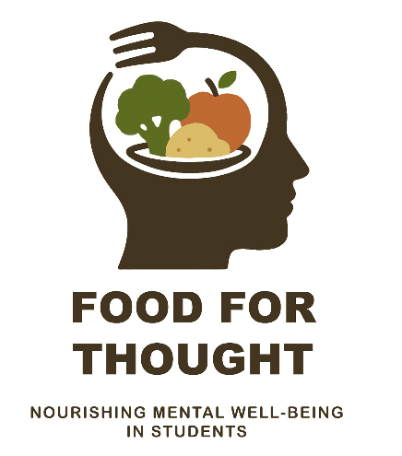
T3.1 – Market Exploration and Shopping
(USAMV Bucharest Report)

Mihaela Geicu-Cristea, Lecturer within the Department of Industrial Biotechnologies, Faculty of Biotechnologies, University of Agronomic Sciences and Veterinary Medicine of Bucharest (USAMV Bucharest), and USAMV Project Responsible for the Erasmus+ KA210-VET project 2025-1-ES01-KA210-VET-000358116, participated in an Erasmus+ mobility hosted by Van Hall Larenstein University of Applied Sciences in Velp, the Netherlands, from 20 to 24 April 2026.
During this mobility, she accompanied a group of first-year VET students enrolled at the Non-University Tertiary College (CTN-USAMV Bucharest) in the professional field of Food Industry. The selected participants represented the following vocational programs:
- Meat and Dairy Processing Program (1 student);
- Bakery and Flour Products Program (1 student);
- Agri-food Quality Control Program (three students).
One of the five selected students was ultimately unable to participate in the mobility due to travel document issues. Although the student had obtained travel insurance, completed check-in procedures, received a boarding pass, and successfully passed airport security screening, boarding was denied because the identity document presented did not meet the travel requirements for international travel. Consequently, the student returned to the university residence hall and did not participate in the mobility. The Erasmus+ mobility therefore proceeded with the remaining four students.
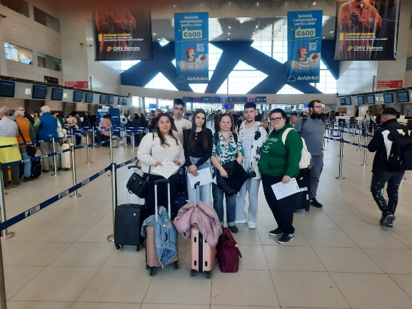 | 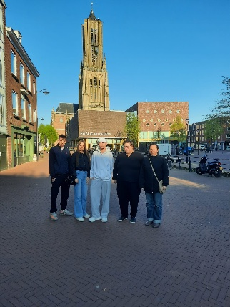
Figure 1. Picture of Romanian group of students and trainer inside the Henri Coandă Otopeni Airport, Romania | Figure 2. Picture of the Romanian group of students and trainer in Arnhem, The Netherlands

The program implemented by the host institution fully followed the approved project agenda and included educational, cultural, and practical activities designed to promote sustainable food systems, intercultural learning, and student well-being.
The main activities included:
- Welcome session, institutional presentation, and guided tour of the Van Hall Larenstein campus;
- Visits to teaching laboratories, greenhouses, classrooms, student facilities, the university kitchen, and the sensory analysis laboratory;
- Interactive ice-breaking session entitled "Food Around the World", encouraging participants to introduce themselves through their national food cultures;
- Expert lectures delivered by Van Hall Larenstein academic staff on "Food Trends – From Farm to Feed" and "Why Do We Buy What We Buy? Shopping Habits and Consumer Behaviour", providing participants with insights into sustainable food systems and consumer decision-making;
- A guided study visit to the Achterhoek region, one of the Netherlands' most important agricultural areas, where participants explored innovative and sustainable food production systems.
The field visits included:
- De Velhorst Farm (Lochem), where participants learned about regenerative organic agriculture, biodiversity conservation, and sustainable cereal production;
- Stadsboerin Doetinchem, an urban social farm promoting community engagement, food education, and social inclusion through sustainable food production. Participants also learned about its involvement in the international Social Gastronomy Movement.
Participants also joined a guided cultural visit to the historic city of Zutphen, followed by independent exploration. During this activity, students experienced local Dutch food culture by visiting traditional bakeries, cafés, and local food retailers.
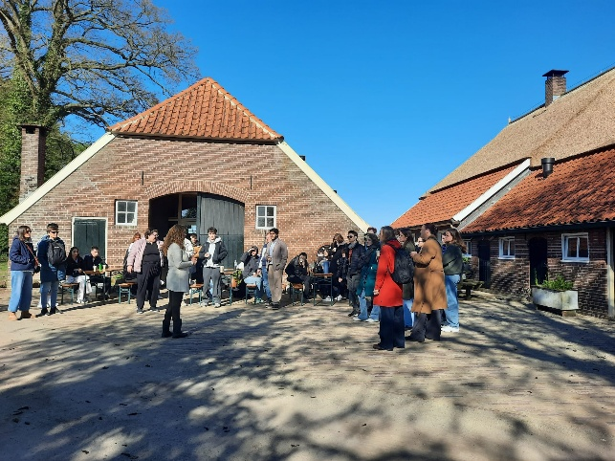 | 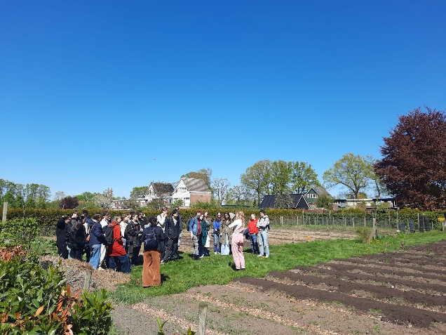
Figure 3. Pictures from De Velhorst Farm (Lochem) Visit
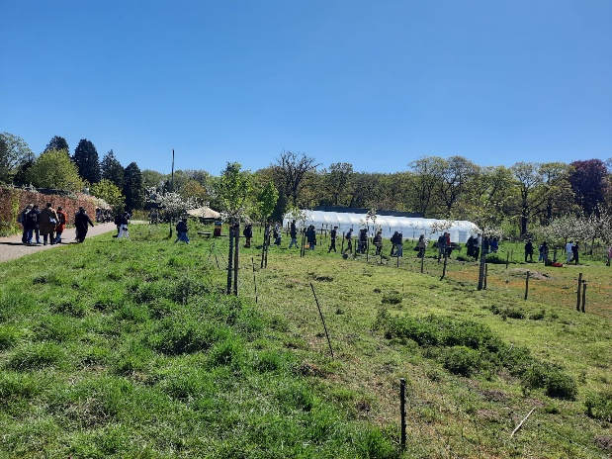 | 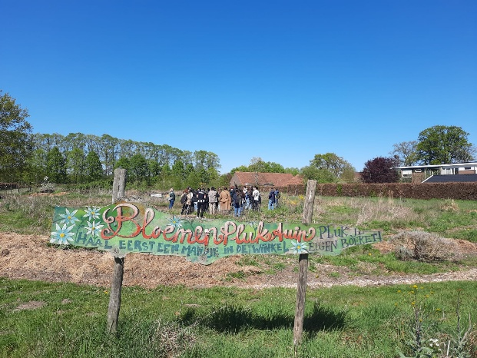
Figure 4. Pictures from Stadsboerin DoetinchemVisit
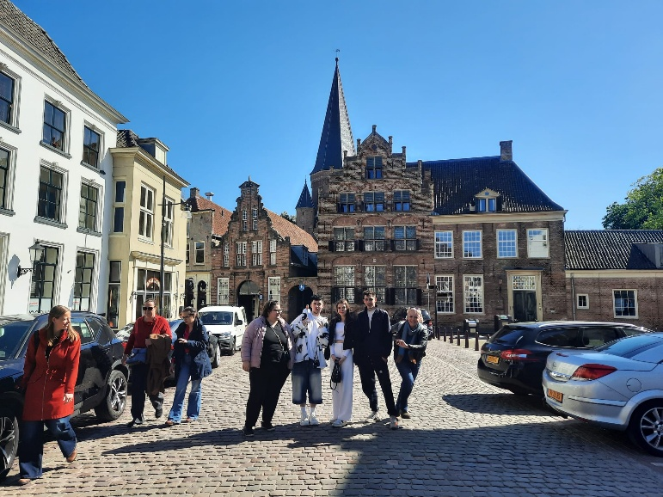 | 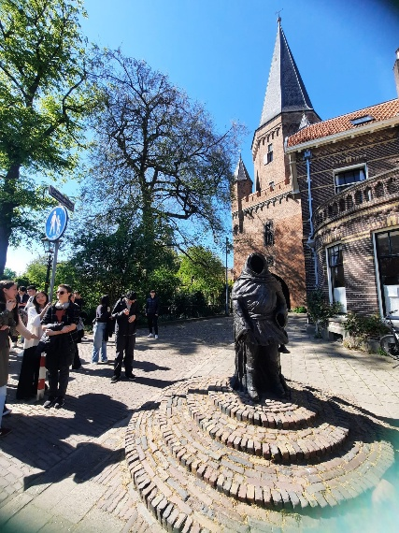
Figure 5. Pictures from the guided cultural visit to the historic city of Zutphen

The Great Intercultural Cook-Off - an important component of the mobility focused on collaborative food planning and preparation. During the Intercultural Cook-Off Planning Session, participants worked in multinational teams coordinated by the ATLAS Student Association and Van Hall Larenstein volunteers. Each team was responsible for designing one course of a multicultural dinner for approximately fifty participants. Every menu was required to incorporate at least one culinary element representing the cultural heritage of one of the participating countries. Teams planned recipes, identified required ingredients, allocated responsibilities, and prepared shopping lists.
As part of the Erasmus+ KA210-VET project activities, participants carried out a guided exploration of local markets and supermarkets in the Netherlands to investigate sustainable food purchasing practices and increase their understanding of responsible consumption within the European food system.
The subsequent "Shop Like a Local" Supermarket Field Trip required each team to visit Dutch supermarkets (including Albert Heijn, Jumbo, Lidl, and local Presikhaaf shopping facilities) to:
- purchase all necessary ingredients while respecting a predefined budget;
- observe consumer behavior and identify at least five differences between Dutch supermarkets and those in their home countries, focusing on store organization, product labelling, sustainability information, product diversity, and pricing strategies.
The activity combined experiential learning with collaborative teamwork, enabling participants to observe and compare food retail environments, consumer purchasing behavior, and sustainability initiatives implemented by different retailers. Participants identified traditional Dutch food products and ingredients, assessed their prices, evaluated seasonal availability, and examined sustainable alternatives, including locally produced, organic, and environmentally certified products. Particular attention was given to product origin, packaging, eco-labels, and information provided to consumers to support sustainable purchasing decisions.
A key component of the activity was the discussion of circular economy principles in the agri-food sector. Participants explored concepts such as short supply chains, local sourcing (km 0), seasonal consumption, food waste reduction, and sustainable procurement. Through guided discussions, they reflected on how these practices contribute to environmental protection, resource efficiency, and the resilience of food systems.
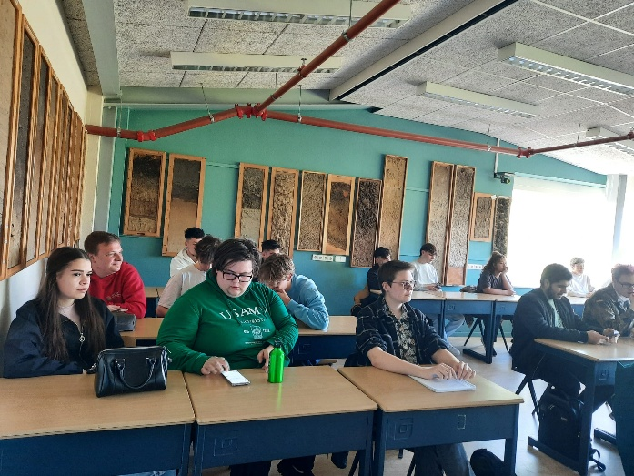 | 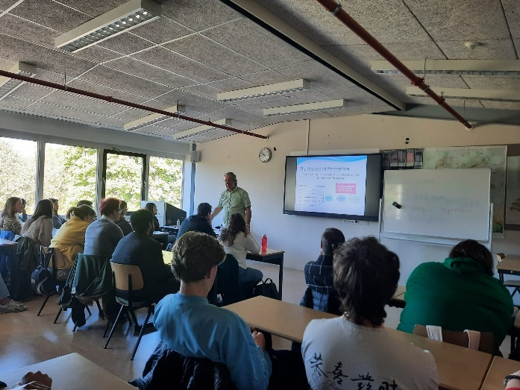
Figure 6. Pictures from guided discussions on food consumers behavior
Working in multinational teams, participants developed a shopping plan within a predefined budget to purchase ingredients required for preparing one traditional dish from each partner country. The teams considered multiple criteria when selecting products, including authenticity, affordability, nutritional value, local availability, and environmental impact. The activity encouraged participants to justify their purchasing decisions based on sustainability principles and economic considerations.
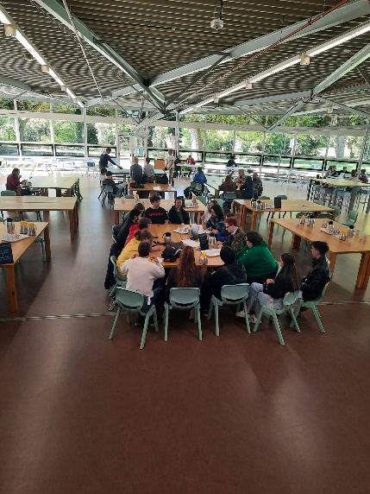 | 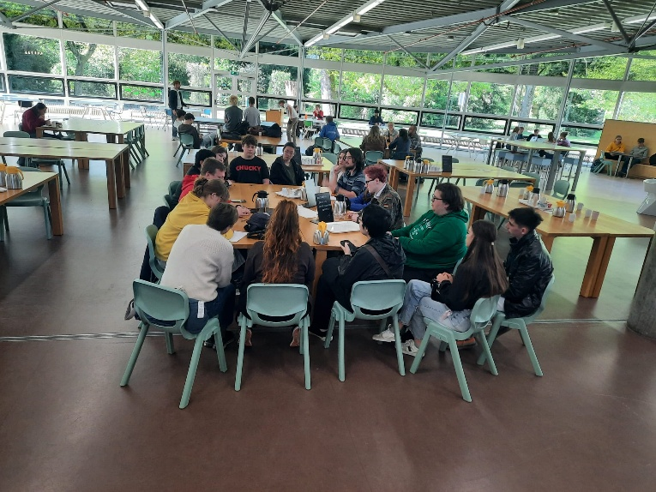
Figure 7. VET Students developing a shopping plan

The learning outcomes of the activity included:
- increased awareness of sustainable food purchasing practices and responsible consumer behavior;
- improved understanding of circular economy principles applied to food systems;
- enhanced competences in budget planning, decision-making, and sustainable procurement;
- strengthened teamwork, intercultural communication, and collaborative problem-solving skills in an international environment;
- improved ability to critically evaluate food products using sustainability, economic, and quality criteria.
The activity successfully linked theoretical knowledge with practical experience, allowing participants to apply sustainability concepts in authentic settings. It contributed directly to the project's objectives of promoting green competences, sustainable food consumption, and vocational skills relevant to the agri-food sector while fostering international cooperation and the exchange of good practices among partner institutions.
The Great Intercultural Cook-Off provided participants with approximately two and a half hours of collaborative cooking. Working in international teams, students prepared their assigned dishes while receiving guidance from university staff and student volunteers.
Following meal preparation, participants organized and decorated the dining area using national colors, flags, and visual representations of their traditional cuisines. Each dish was accompanied by a handwritten information card explaining its cultural origin and significance.
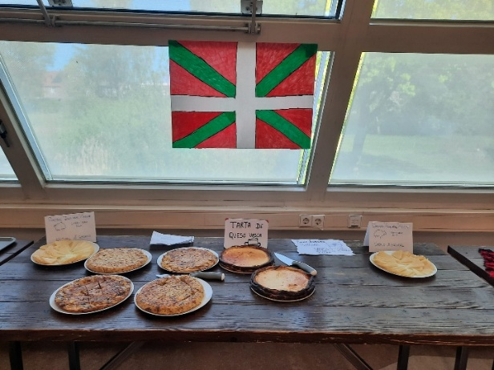 | 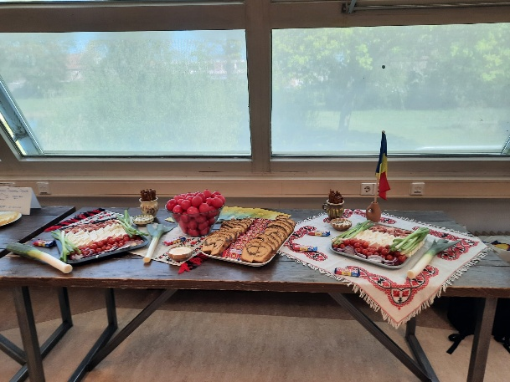
Figure 8. Decorated dining area with Spain flag | Figure 9. Decorated dining area with Romanian flag and traditional hand-sewn tablecloths

The mobility culminated in the "A Table Without Borders" Intercultural Dinner, which served as the flagship event of the week. Before serving each course, participating teams presented the story behind their dishes, highlighting cultural traditions and the significance of the selected ingredients. The dinner brought together students, academic staff, and volunteers in an atmosphere that promoted intercultural dialogue and social interaction. Following the main course, participants engaged in a round-table reflection discussing how the week's activities had influenced their perspectives on food, sustainability, and cultural diversity. Awards were presented for creativity, the most original ingredient, and the best overall presentation.
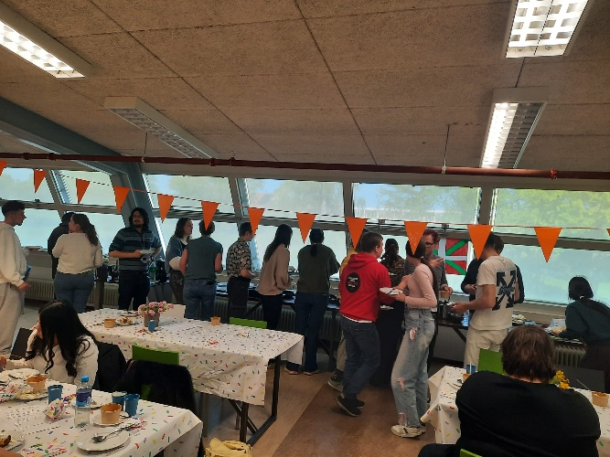 | 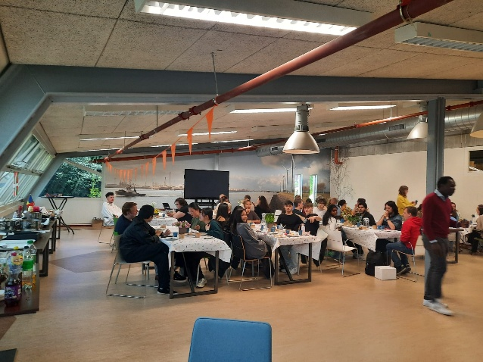
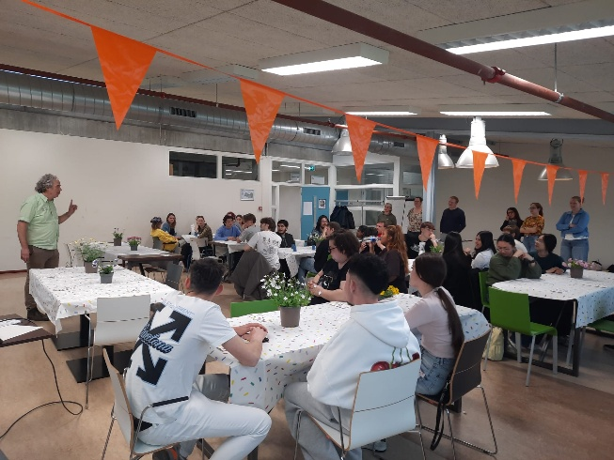 | 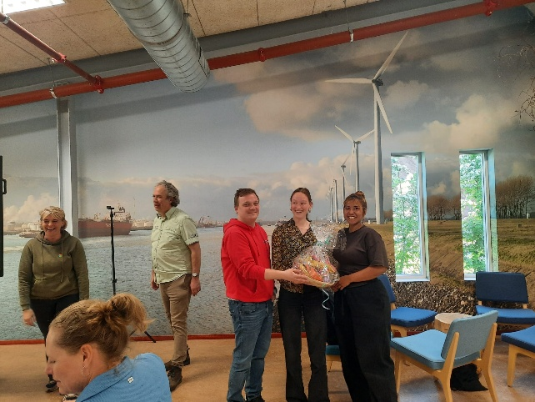
Figure 10. Images from the "A Table Without Borders" Intercultural Dinner

- Activity Overview on T3.1 – Market Exploration and Shopping
As part of the Erasmus+ KA210-VET project Food for Thought: Nourishing Mental Well-being in Vocational Training, participants visited several Dutch supermarkets, including Albert Heijn, Jumbo, Lidl, and local stores in the Presikhaaf shopping area. The objective was to observe consumer behaviour and compare the shopping experience with that of supermarkets in Romania, with particular attention to store organisation, product labelling, sustainability practices, product diversity, and pricing strategies.

Consumer Behaviour
Students observed that Dutch consumers generally approached shopping in a well-organized and planned manner. Many shoppers used reusable shopping bags and bicycles for transporting groceries, reflecting the widespread adoption of environmentally responsible habits. Consumers appeared to spend time reading product labels and comparing nutritional information, country of origin, and sustainability certifications before making purchasing decisions. A noticeable proportion of customers purchased fresh produce, bakery items, dairy products, and ready-to-eat meals. Self-service checkouts were widely used and accepted, allowing customers to complete purchases quickly with minimal staff assistance.

Main Differences Identified

1. Store Organisation
Dutch supermarkets were organized to facilitate a smooth shopping experience. Fresh fruit and vegetables were positioned at the entrance, followed by bakery, dairy, refrigerated products, and packaged foods. Signage was clear, shelves were well stocked, and dedicated areas highlighted seasonal or locally produced products. In Romanian supermarkets, while product organization is generally similar, promotional displays are more prominent, and local products are not always grouped or clearly highlighted.

2. Product Labelling
Dutch products provided comprehensive information, including nutritional values, allergens, origin, recycling instructions, animal welfare labels, and sustainability certifications. Eco-labels such as organic certification and environmental quality marks were frequently displayed and easy to identify. Romanian supermarkets also comply with European labelling regulations; however, sustainability-related information is generally less visible, and consumers are less frequently guided towards environmentally responsible purchasing choices through shelf labelling.

3. Sustainability Information
One of the most evident differences was the strong emphasis on sustainability in Dutch supermarkets. Participants observed dedicated sections for organic products, locally sourced foods, vegetarian and plant-based alternatives, and products with reduced environmental impact. Information encouraging recycling, reducing food waste, and choosing sustainable packaging was displayed throughout the stores. Several supermarkets also promoted discounted products approaching their expiration date as part of food waste reduction initiatives. In Romania, although organic and eco-friendly products are increasingly available, sustainability messaging is generally less prominent and occupies a smaller proportion of retail space.

4. Product Diversity
Dutch supermarkets offered a wide variety of international foods alongside traditional Dutch products. Participants noted an extensive selection of vegetarian, vegan, gluten-free, lactose-free, and organic products. Ready-to-cook meals and convenience foods were also available in numerous varieties. Romanian supermarkets provide an increasingly diverse product range; however, the selection of specialized products remains more limited, particularly in smaller cities and local supermarkets.

5. Pricing Strategies
Dutch supermarkets used a variety of pricing strategies, including loyalty discounts, multi-buy offers, dynamic pricing for products nearing their expiry date, and promotional campaigns encouraging sustainable purchasing. Price labels were clear and often included the price per kilogram or liter, facilitating comparison between products. Participants observed that many sustainable or organic products were more expensive than conventional alternatives. However, retailers frequently offered promotions that made these products more affordable. In Romania, promotional pricing is also common, but discounts are more frequently applied through weekly offers and catalogue promotions rather than sustainability-focused initiatives.
6. Additional Observations regarding Fresh Produce Section and Sustainable Packaging
One of the most notable observations during the supermarket visits was the organization and maintenance of the fresh fruit and vegetable section. In all supermarkets visited, this department was located near the entrance, creating an attractive first impression and encouraging consumers to purchase fresh products.
Participants observed that many fresh fruits and vegetables were periodically sprayed with a fine water mist to maintain their freshness, appearance, and shelf life. This automated misting system helps preserve moisture, reduces dehydration, and improves the visual quality of perishable produce without the need for excessive refrigeration. Such systems contribute to reducing food waste by extending the marketable life of fresh products while maintaining their quality.
Another aspect that attracted participants' attention was the packaging and presentation of fresh produce. Dutch supermarkets offered a balanced combination of loose (unpackaged) fruits and vegetables and pre-packed products. Consumers were encouraged to purchase loose produce, allowing them to select the exact quantity needed and thereby helping to reduce household food waste.
When packaging was used, it was generally designed with sustainability in mind. Participants observed:
- recyclable cardboard trays replacing plastic packaging for several fruit and vegetable products;
- paper bags available for fresh produce instead of single-use plastic bags;
- compostable or recyclable plastic packaging for products requiring additional protection;
- clear labelling indicating the country of origin, production method (conventional or organic), and sustainability certifications where applicable;
- packaging designed to minimize material use while maintaining product quality and food safety.
Several supermarkets also promoted locally grown seasonal produce through dedicated displays and signage, encouraging consumers to choose products with a lower environmental footprint. Organic fruits and vegetables were clearly separated and labelled, making sustainable choices easier for consumers. Compared with supermarkets in Romania, participants noted that although loose fruits and vegetables are widely available, automated misting systems are rarely used, and plastic packaging remains more common for many fresh products. In addition, sustainable packaging alternatives such as cardboard trays, compostable bags, and extensive environmental labelling were observed more frequently in Dutch supermarkets. These observations demonstrated how supermarket design, produce preservation technologies, and environmentally conscious packaging can simultaneously improve product quality, reduce food losses, and support more sustainable consumer behavior.

Learning Outcomes
The activity enabled participants to critically analyze food retail environments from both consumer and sustainability perspectives. They developed a better understanding of how supermarket organization, product information, and pricing strategies influence purchasing decisions and consumer behavior.
The comparison highlighted the advanced integration of sustainability principles within Dutch food retail and encouraged participants to reflect on how similar practices could be promoted in Romania. The experience strengthened participants' awareness of responsible consumption, sustainable food systems, and informed purchasing decisions, contributing directly to the objectives of the Erasmus+ KA210-VET project.

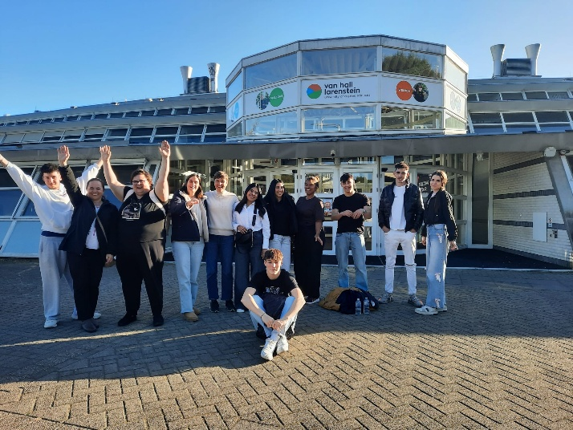 | 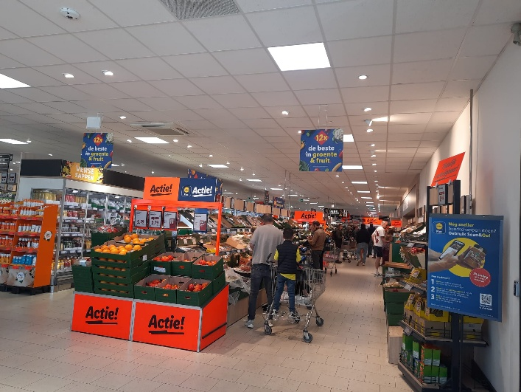
Figure 11. Vet students and trainers from Spain and Romania after completing activity 3 at Van Hall Larenstein, in Velp -The Netherlands | Figure 12. Aspects during the shopping for food ingredients in the LIDL supermarket in Velp, The Netherlands

As Project Responsible for USAMV Bucharest partner, Mihaela Geicu-Cristea was responsible for supervising and supporting the participating students throughout the mobility, ensuring their well-being and active participation in all scheduled activities. She also coordinated all organizational and financial aspects related to travel and mobility implementation. Travel and mobility expenses were fully covered by the Erasmus+ project budget, with an allocated mobility budget of EUR 5,480 for the activities carried out in the Netherlands.
The mobility successfully achieved its educational objectives by strengthening participants' understanding of sustainable food systems, responsible consumer behavior, intercultural collaboration, and vocational competences related to the food sector. Furthermore, it contributed significantly to the project's overarching goal of promoting mental well-being through shared culinary experiences, teamwork, and intercultural exchange.
All activities foreseen under the Work Package "From Shopping to Cooking: Exploring Culinary Choices and Flavors in the Cultures of VET Students" were successfully implemented in accordance with the approved work plan of the Erasmus+ KA210-VET project FOODFORTHOUGHT.

